Slide Deck Instructions:

Slide 1: Logo – Product
Slide 2: High-level overview of Product/Service/Platform
  - 15 of the top 20 hospitals in US
  - Used in more than 60% of hospitals
  - Nation’s fastest recall system (27 days earlier than industry sources)
Slide 3:
Alert Content Team consists of dedicated alert analysts to ensure maximum capture of alerts and timeliness of alert delivery.
●OneRecallalerts go through a rigorous process of information verification including scope, alert detail and status ensuring our subscribers have the most up-to-date information.
●OneRecallalerts are processed within 4-8 hours (alert source verification may extend this timeline)
●Urgent alerts have top priority over standard alerts.
●Direct relationship with manufacturers and wholesalers allows faster delivery of alerts to our subscribers.

Slide 4: Department Mapping / Role Assignment:

Tier 1 – Recall Coordinator
Oversees inventory in their department(s)
Receives direct emails from platform requesting inventory checks, has access to enter data in the platform, and closes recalls.

Tier 2 – Materials Manager/Facility Point Person
Receives direct emails from platform requesting inventory checks. Can re-route to other department if needed. Can close out recalls on other departments behalf. Can add / remove users.

Tier 3 – Recall Manager/Administrator
Oversees. Can escalate. Can update and close recalls. Can re-route recalls to other departments. Can add/remove users. Can add/remove departments. Has access to reporting tools.
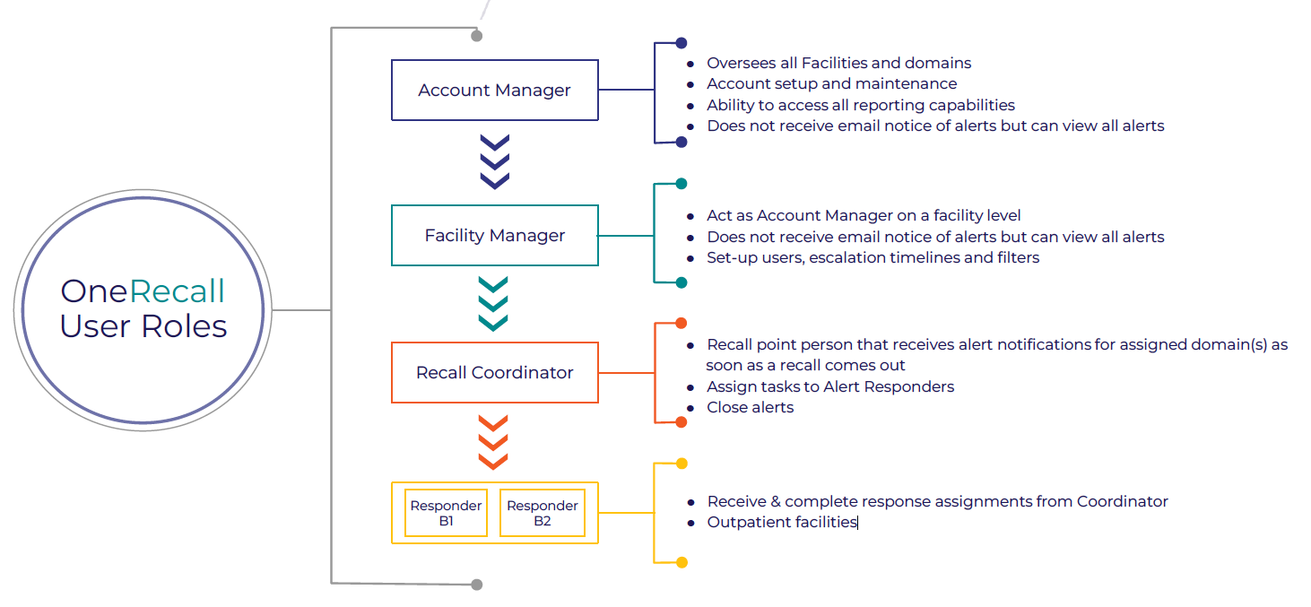

Slide 5: Escalation Rules – Custom or Tier based
Slide 6: AI Overview:
●OneRecall incorporates rapidID technology which compares a user’s purchase history information with each notification released by OneRecall, automatically notifying users when they are affected by recalls
●The improved tool yields accurate history/recall matches through newly developed algorithms, and its efficiency cuts costsby removing products from shelves faster
●Processing time is decreased by up to 80%, through OneRecall and rapidID, which reduces patient exposure to potentially harmful products and saves lives
8
Slide 7: Management Reporting:
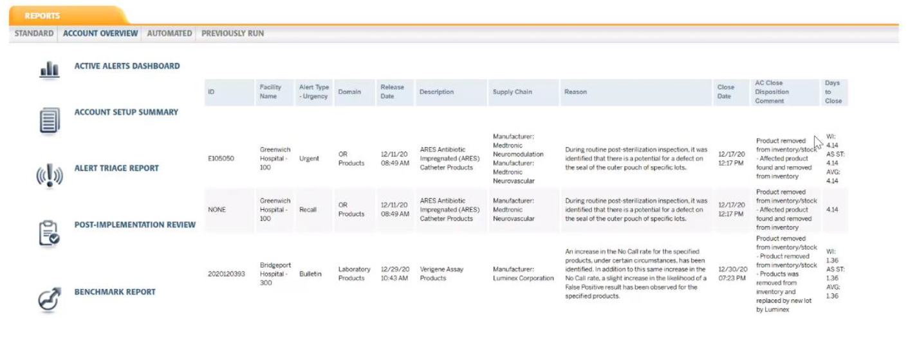

Slide 8: Client Support and Resources
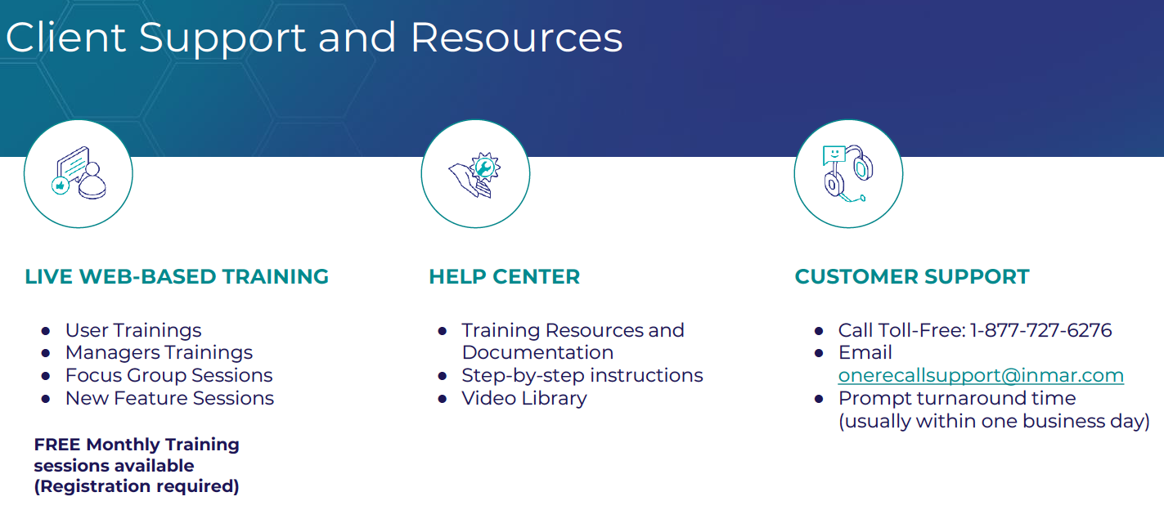
Slide 9: End/Info/How to get started

Name Drops:
BJC Healthcare
Greenwich Hospital – 100
Bridgeport Hospital – 300

Inmar claims to have 15 of 20 of these. This doesn’t include Sinai. At least we know who our direct competition is, and I have already reviewed their platform and I have their latest slide deck.

https://www.usnews.com/info/blogs/press-room/articles/2025-07-29/u-s-news-announces-2025-2026-best-hospitals

WASHINGTON, D.C. – U.S. News & World Report, the global authority in health care rankings and ratings, today released the 2025-2026 edition of Best Hospitals, the 36th year of this annual study.
The 2025-2026 edition of Best Hospitals includes the regional evaluation of hospitals at both a state and metro level. This year, U.S. News recognizes 504 Best Regional Hospitals across 49 states and 95 metro areas that have demonstrated superior outcomes.
“For most Americans, health care decisions are made close to home. The Best Regional Hospitals rankings underscore the difference high-performing local medical centers make,” said Ben Harder, chief of health analysis and managing editor at U.S. News.
Harder added, “These local hospital rankings, entirely performance-driven, equip individuals and their families, in consultation with their medical providers, to choose the highest quality care available in their own communities.”
2025-2026 Best Regional Hospitals, Metro Highlights
The Best Regional Hospitals for 25 of the most-populous U.S. metropolitan areas are shown below. These hospitals are recognized as No. 1 or tied for No. 1 and are listed alphabetically by metropolitan area.
- Atlanta: Emory University Hospital, No. 1 out of 10 Best Hospitals near Atlanta
- Baltimore: Johns Hopkins Hospital, No. 1 out of 4 Best Hospitals near Baltimore
- Boston: Brigham and Women's Hospital and Massachusetts General Hospital, No. 1 (tied) out of 10 Best Hospitals near Boston
- Chicago: Northwestern Medicine-Northwestern Memorial Hospital and Rush University Medical Center, No. 1 (tied) out of 21 Best Hospitals near Chicago
- Cleveland: Cleveland Clinic, No. 1 out of 6 Best Hospitals near Cleveland
- Dallas-Fort Worth: UT Southwestern Medical Center, No. 1 out of 9 Best Hospitals near Dallas-Fort Worth
- Denver: UCHealth University of Colorado Hospital, No. 1 out of 5 Best Hospitals near Denver
- Detroit: University of Michigan Health-Ann Arbor, No. 1 out of 11 Best Hospitals near Detroit
- Houston: Houston Methodist Hospital, No. 1 out of 12 Best Hospitals near Houston
- Los Angeles: Cedars-Sinai Medical Center and UCLA Medical Center, No. 1 (tied) out of 24 Best Hospitals near Los Angeles
- Miami-Fort Lauderdale: Cleveland Clinic Weston, No. 1 out of 10 Best Hospitals near Miami-Fort Lauderdale
- Minneapolis-St. Paul: M Health Fairview University of Minnesota Medical Center, No. 1 out of 9 Best Hospitals near Minneapolis-St. Paul
- New York: Hackensack University Medical Center at Hackensack Meridian Health, Mount Sinai Hospital, New York-Presbyterian Hospital-Columbia and Cornell and NYU Langone Hospitals, No. 1 (tied) out of 25 Best Hospitals near New York
- Orlando: AdventHealth Orlando, No. 1 out of 3 Best Hospitals near Orlando
- Philadelphia: Hospitals of the University of Pennsylvania-Penn Presbyterian, No. 1 out of 12 Best Hospitals near Philadelphia
- Phoenix: Mayo Clinic-Arizona, No. 1 out of 5 Best Hospitals near Phoenix
- Raleigh-Durham: Duke University Hospital, No. 1 out of 6 Best Hospitals near Raleigh-Durham
- Riverside-San Bernardino: Loma Linda University Medical Center, No. 1 out of 3 Best Hospitals near Riverside-San Bernardino
- Sacramento: UC Davis Medical Center, No. 1 out of 7 Best Hospitals near Sacramento
- San Antonio: Methodist Hospital-San Antonio, No. 1 out of 3 Best Hospitals near San Antonio
- San Diego: UC San Diego Health-La Jolla, Hillcrest, and East Campus Medical Centers, No. 1 out of 8 Best Hospitals near San Diego
- San Francisco: UCSF Health-UCSF Medical Center, No. 1 out of 9 Best Hospitals near San Francisco
- Seattle: Virginia Mason Medical Center, No. 1 out of 10 Best Hospitals near Seattle
- Tampa-St. Petersburg: Tampa General Hospital, No. 1 out of 7 Best Hospitals near Tampa-St. Petersburg
- Washington, D.C.: Inova Fairfax Hospital, No. 1 out of 9 Best Hospitals near Washington, D.C.

Hypothetically all 89 accounts at 10% of 40K = $356,000
$70,000 – in additional bonuses
$100,000 each in bonus salary.

Year 1 Incentive – New Business
$10,000 bonus = 10-14
+$5,000 bonus = 15-19
+$15,000 bonus = 20-24
+$5,000 bonus = 25-30
+$5,000 bonus = 31-40
+15,000 bonus = 41-50
+15,000 bonus = 51-60
$100,000 base salary x 2 = 60+
($70,000 additional bonuses)

